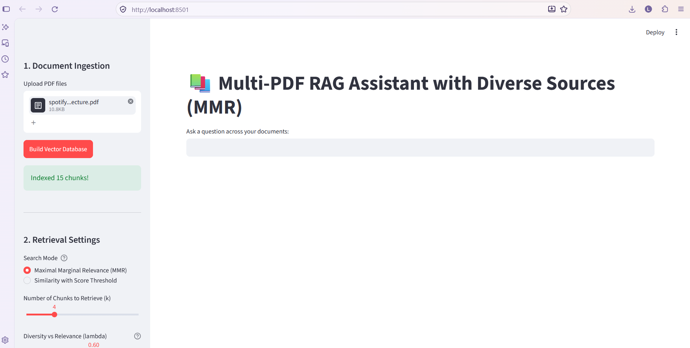
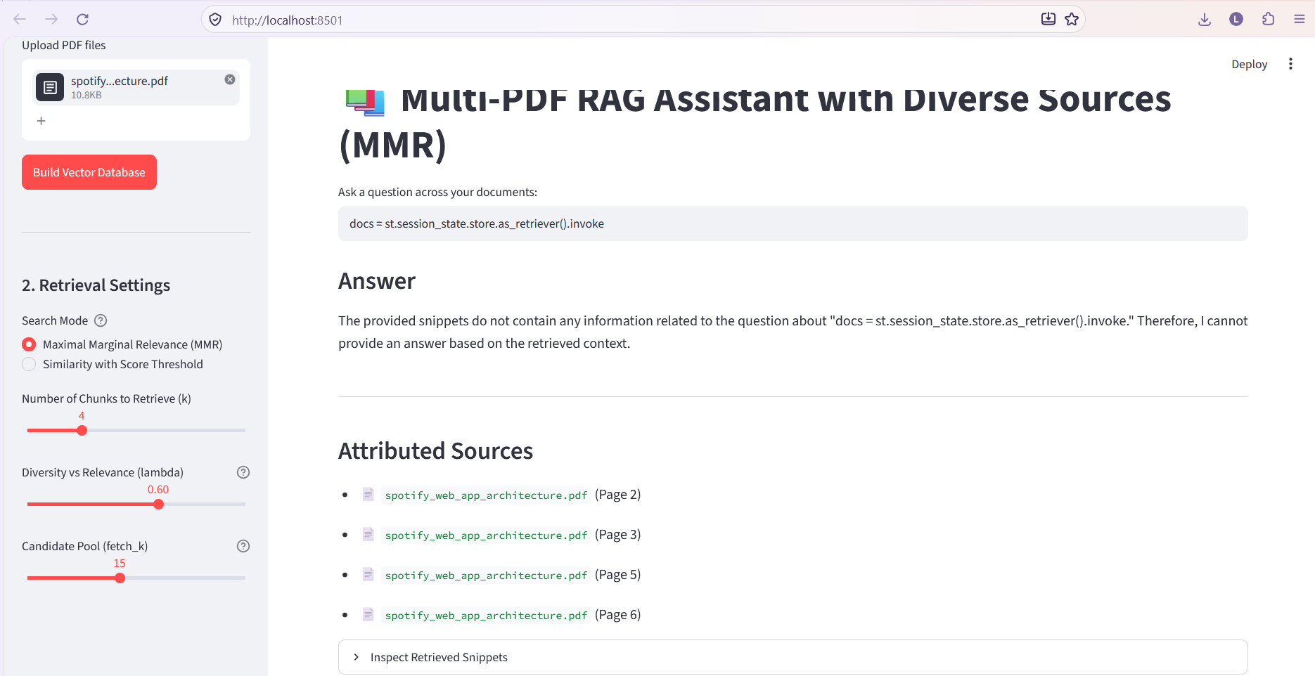

Answers to the "Think It Through" Questions
- Handling Disagreements Between Documents:
  - Standard naive RAG quietly picks whichever snippet the model processes first or blends them into hallucinations.
  - In this script, each chunk is formatted into the prompt as [Snippet X | File: <filename> | Page: <page>]. The system prompt enforces: "If multiple documents disagree, contradict each other, or offer differing perspectives, EXPLICITLY highlight the discrepancy (e.g., 'File A states X, whereas File B states Y') instead of picking one."
- Chunk Size & Source Dispersion:
  - If a single focused answer cites five different pages, chunks are likely too small (fragmenting sentences across page breaks) or retrieval parameter $k$ is pulling redundant fragments.
  - Setting chunk_size=1000 with chunk_overlap=150 maintains sufficient paragraph-level context per chunk, keeping citation counts focused on 1–3 relevant pages per topic.

